Brennan, Paul (from Linked In)
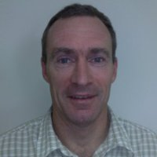

BSc Forestry ANU 1985. Timbind Prize - final year of BSc (For.). The University of Western Australia MSc (NRM), Natural Resource Economics 1993–1995. Southern Cross University MBA, Business Administration and Management, 2002–2004. Link Training Cert IV Assessment & Workplace Training 2005. HiLogic Certificate, Prince2 Project Management Practitioner 2011.

Various positions with WA Department of CALM 1985–1995. Management of natural areas and stakeholders - conservation reserves & multiple-use forests, various locations & operations; bushfire protection planning & incident response. Assistant Divisional Forest Officer at Busselton in 1989, at Kelmscott Inventory in 1991. Operations Manager & Team Leader, Expert Systems Forests NSW 1995–2004. Delivery of a large-scale revegetation project (eucalypt plantations); management & development of team (staff & contractors), related practices & policy; bushfire protection planning & incident control. Senior Natural Resources, Environment and Principal Forestry Consultant GHD 2004–2006. Manager, Strategic Projects Forest Products Commission, W.A. 2006–2011. Business Development Manager Forest Products Commission, W.A. May 2011 – November 2011. Senior Principal Policy & Projects WA Dept. National Parks & Wildlife December 2011 – , Perth (Kensington).

